Previous N quarters comparison

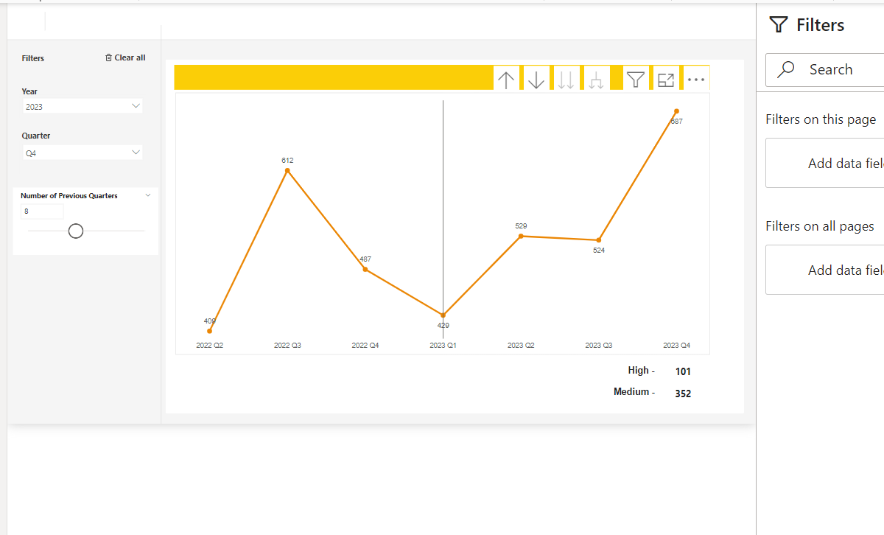

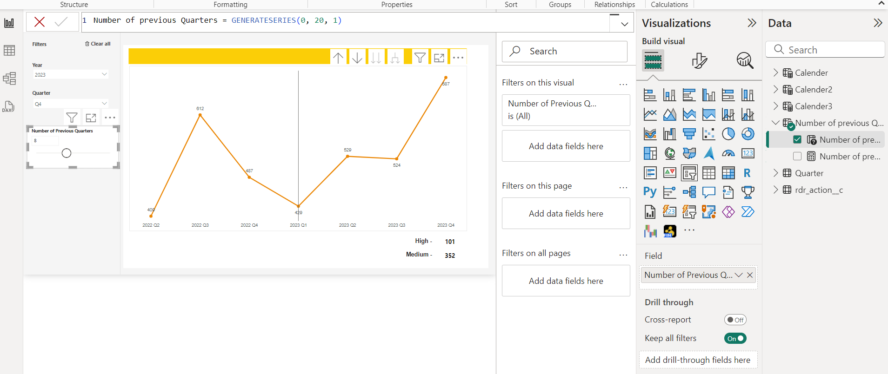

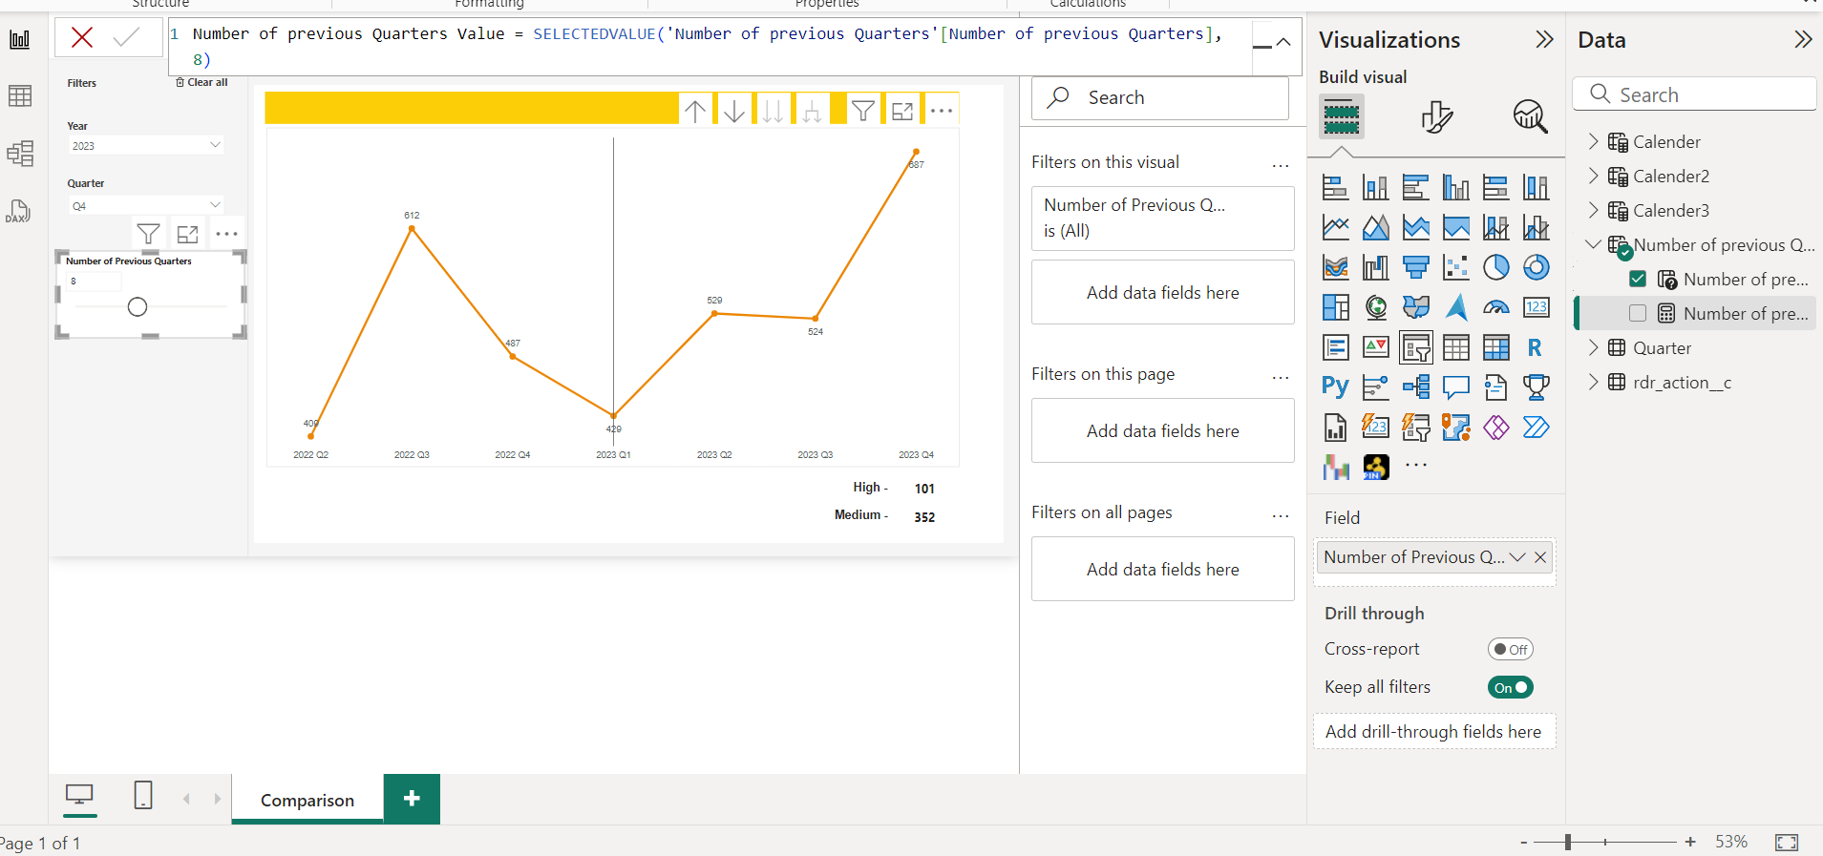

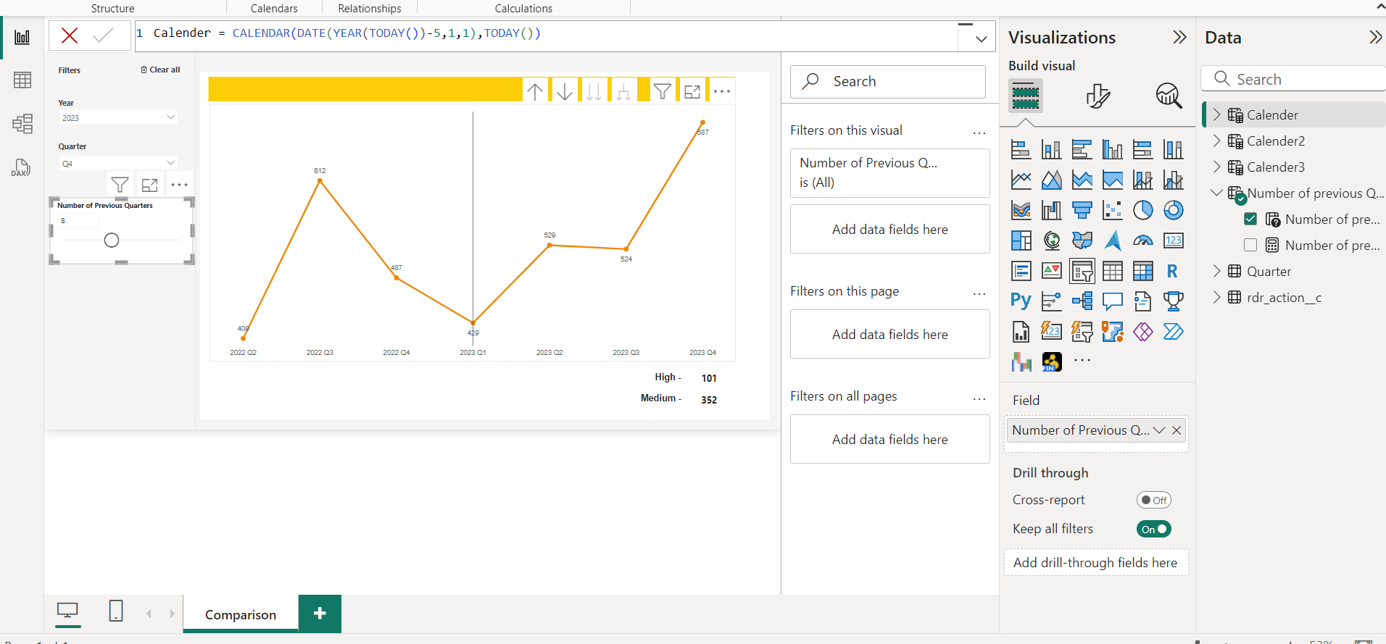

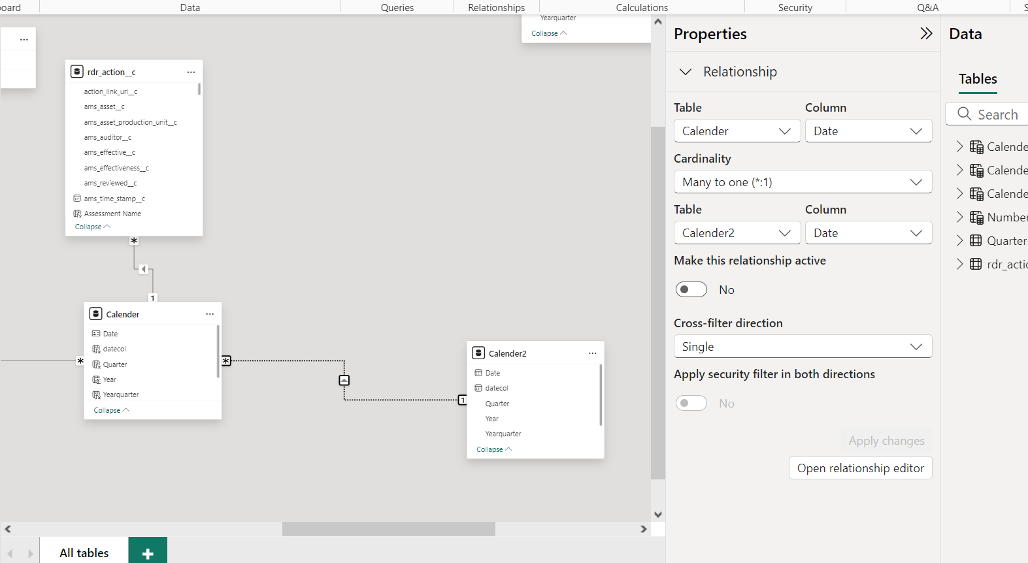

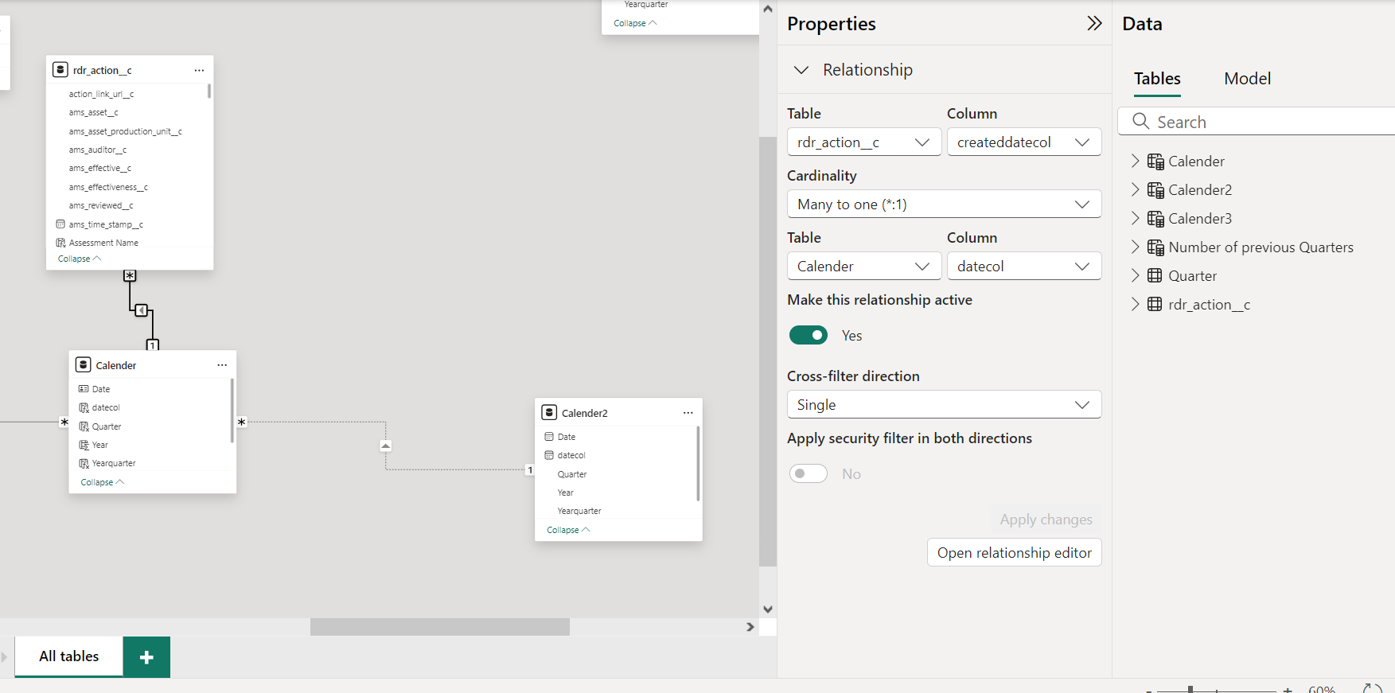

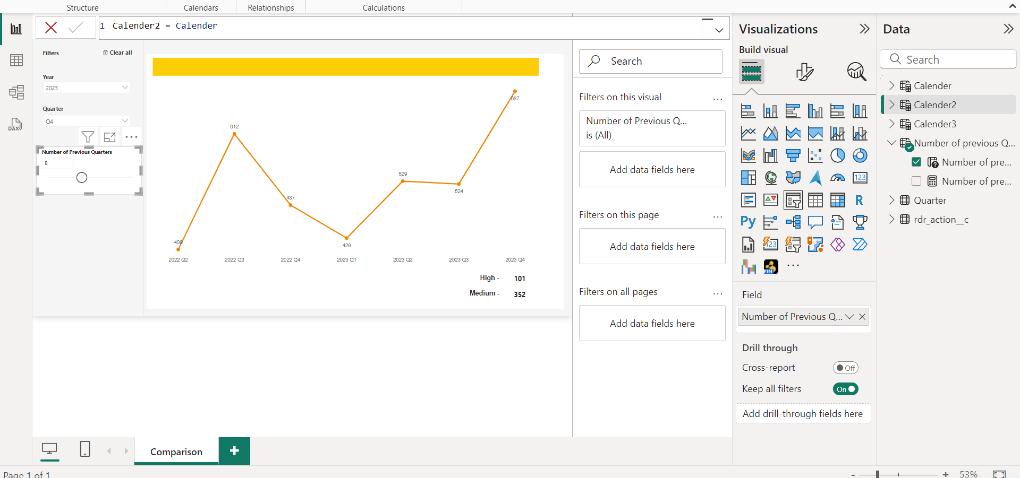

DAX:

Overdue =

var _max =max(Calender[Date])

var _lastperiod =

 DATESINPERIOD(Calender2[Date],

                _max,-'Number of previous Quarters'[Number of previous Quarters Value]+1, QUARTER)

RETURN

CALCULATE(

    [Overdue actions],

    REMOVEFILTERS(Calender),

    KEEPFILTERS(_lastperiod),

    USERELATIONSHIP(Calender[Date],Calender2[Date])

)

